# **Name: Abdurrahman Qureshi**

# **Roll No: 242466**

Practical No: 13

Date Of Performance: 10/10/2025

Aim: To understand continuous monitoring by installing and configuring Nagios Core and Nagios Plugins on a Linux machine and exploring the monitoring dashboard services.

1. What is Nagios? Comment on why we need Nagios tool?
2. Perform an experiment, to Understand Continuous monitoring and Installation and configuration of Nagios Core, Nagios Plugins on Linux Machine.
3. Login to Nagios dashboard and just list any 5 services available of dashboard

[Terminate the resources after performing the practical- terminate Ec2 ]

ANS.1:

Nagios is an open-source continuous monitoring system that monitors network services, host resources, and server components.

We need Nagios tool because:

* It provides proactive problem detection before infrastructure issues affect business operations
* Enables automated alerting and notifications when services fail
* Offers comprehensive infrastructure monitoring of networks, servers, applications, and services
* Supports performance tracking and capacity planning through historical data
* Ensures high availability of critical IT infrastructure components
* Provides centralized monitoring dashboard for entire IT environment

ANS.3:

* Current Load - Monitors CPU load average and processor utilization
* Current Users - Tracks number of users currently logged into the system
* HTTP - Monitors web server availability and response time
* PING - Checks host reachability using ICMP ping protocol
* Root Partition - Monitors disk space usage on the root filesystem

ANS.2:

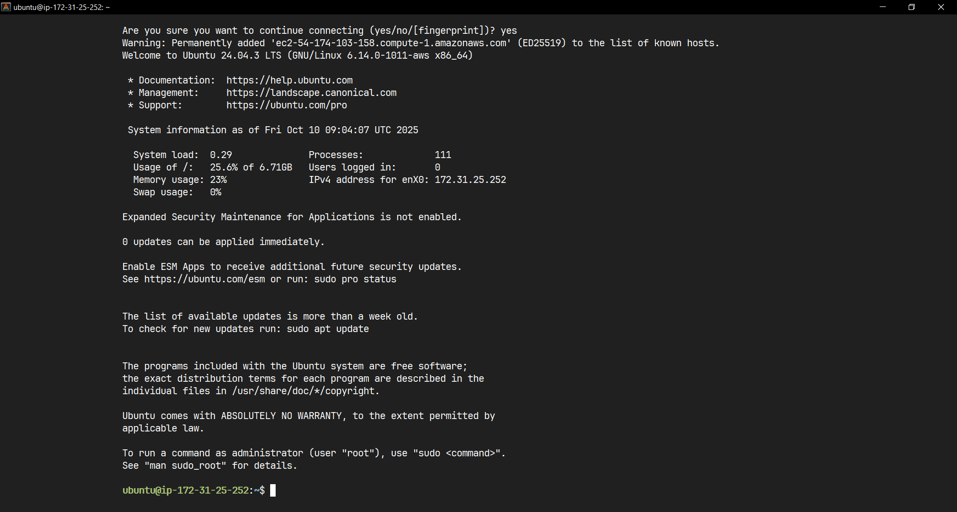

Connected to an Ubuntu EC2 Instance successfully

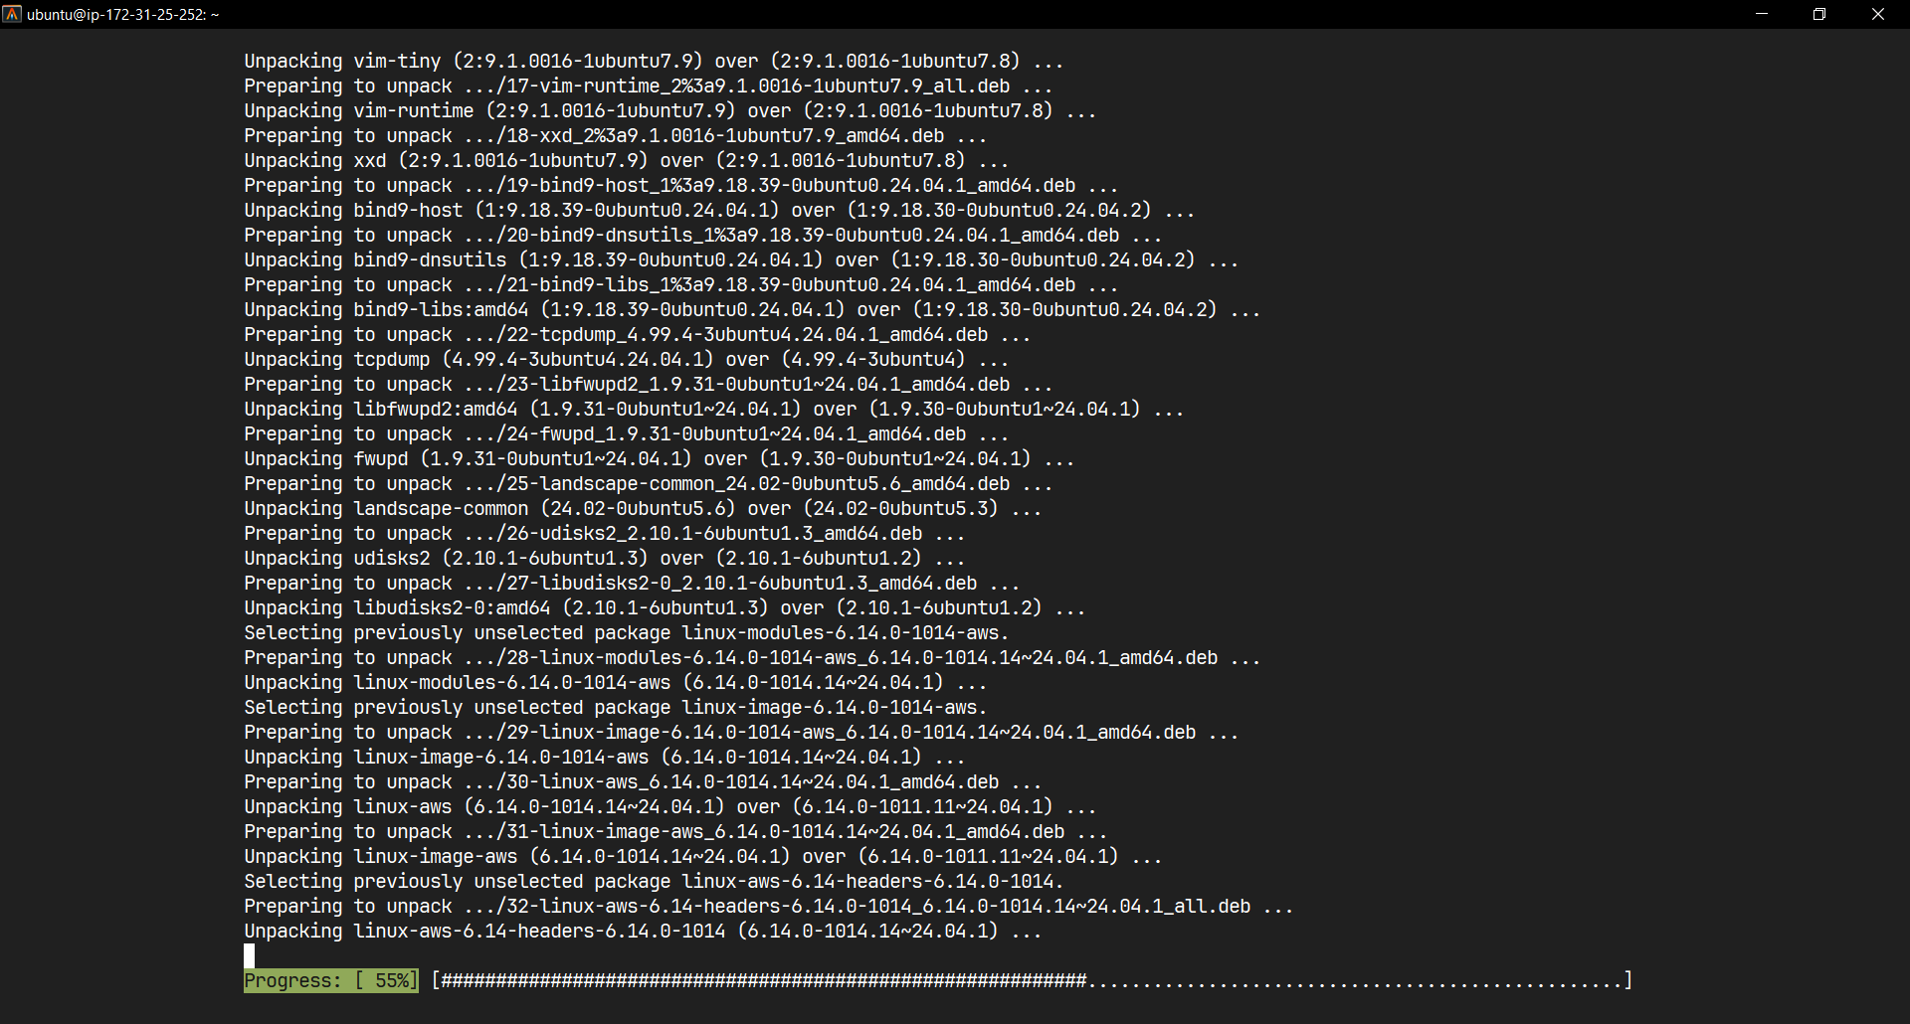

Updating and Upgrading Ubuntu System

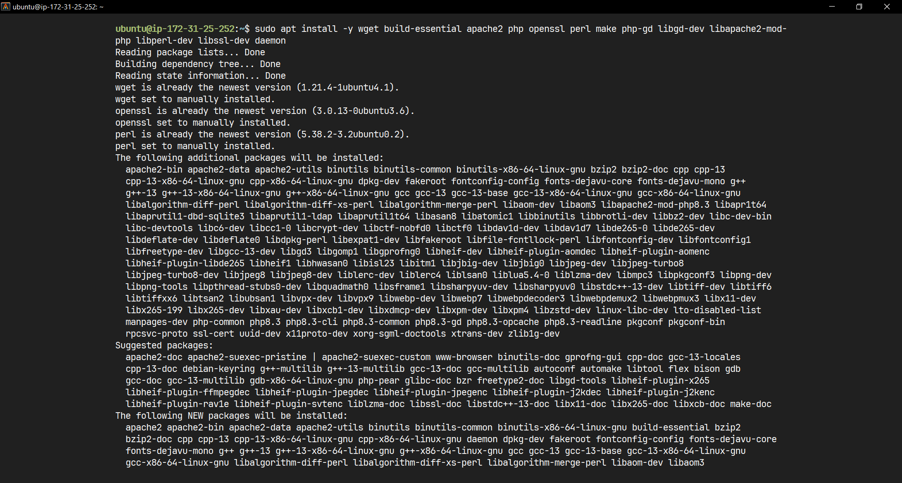

Installing required dependencies

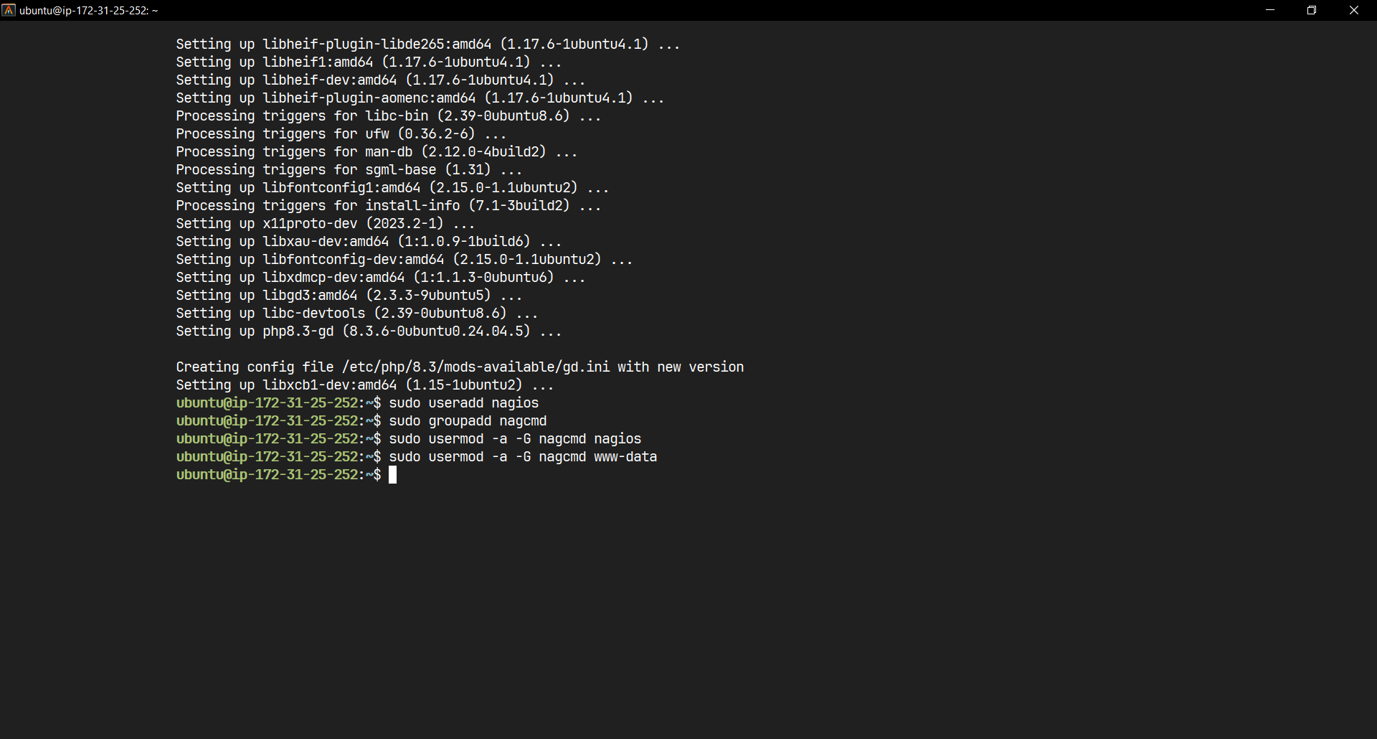

Create Nagios User and Group

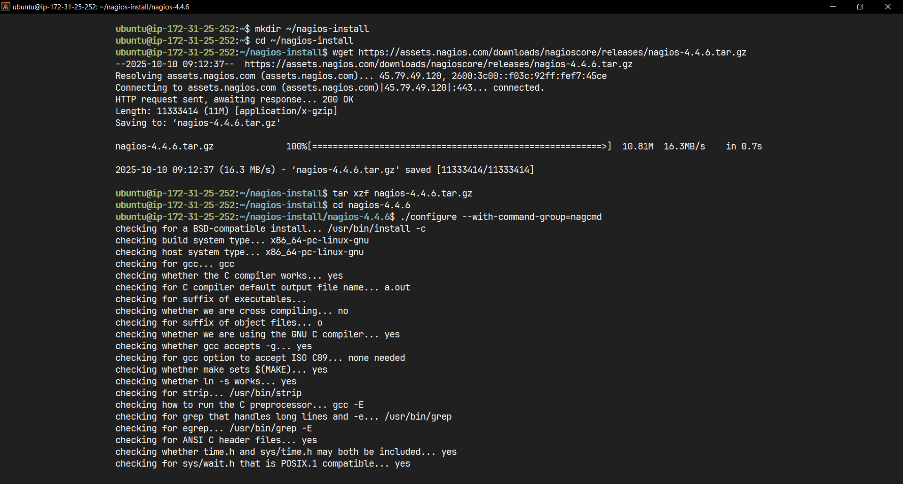

Download and Install Nagios Core

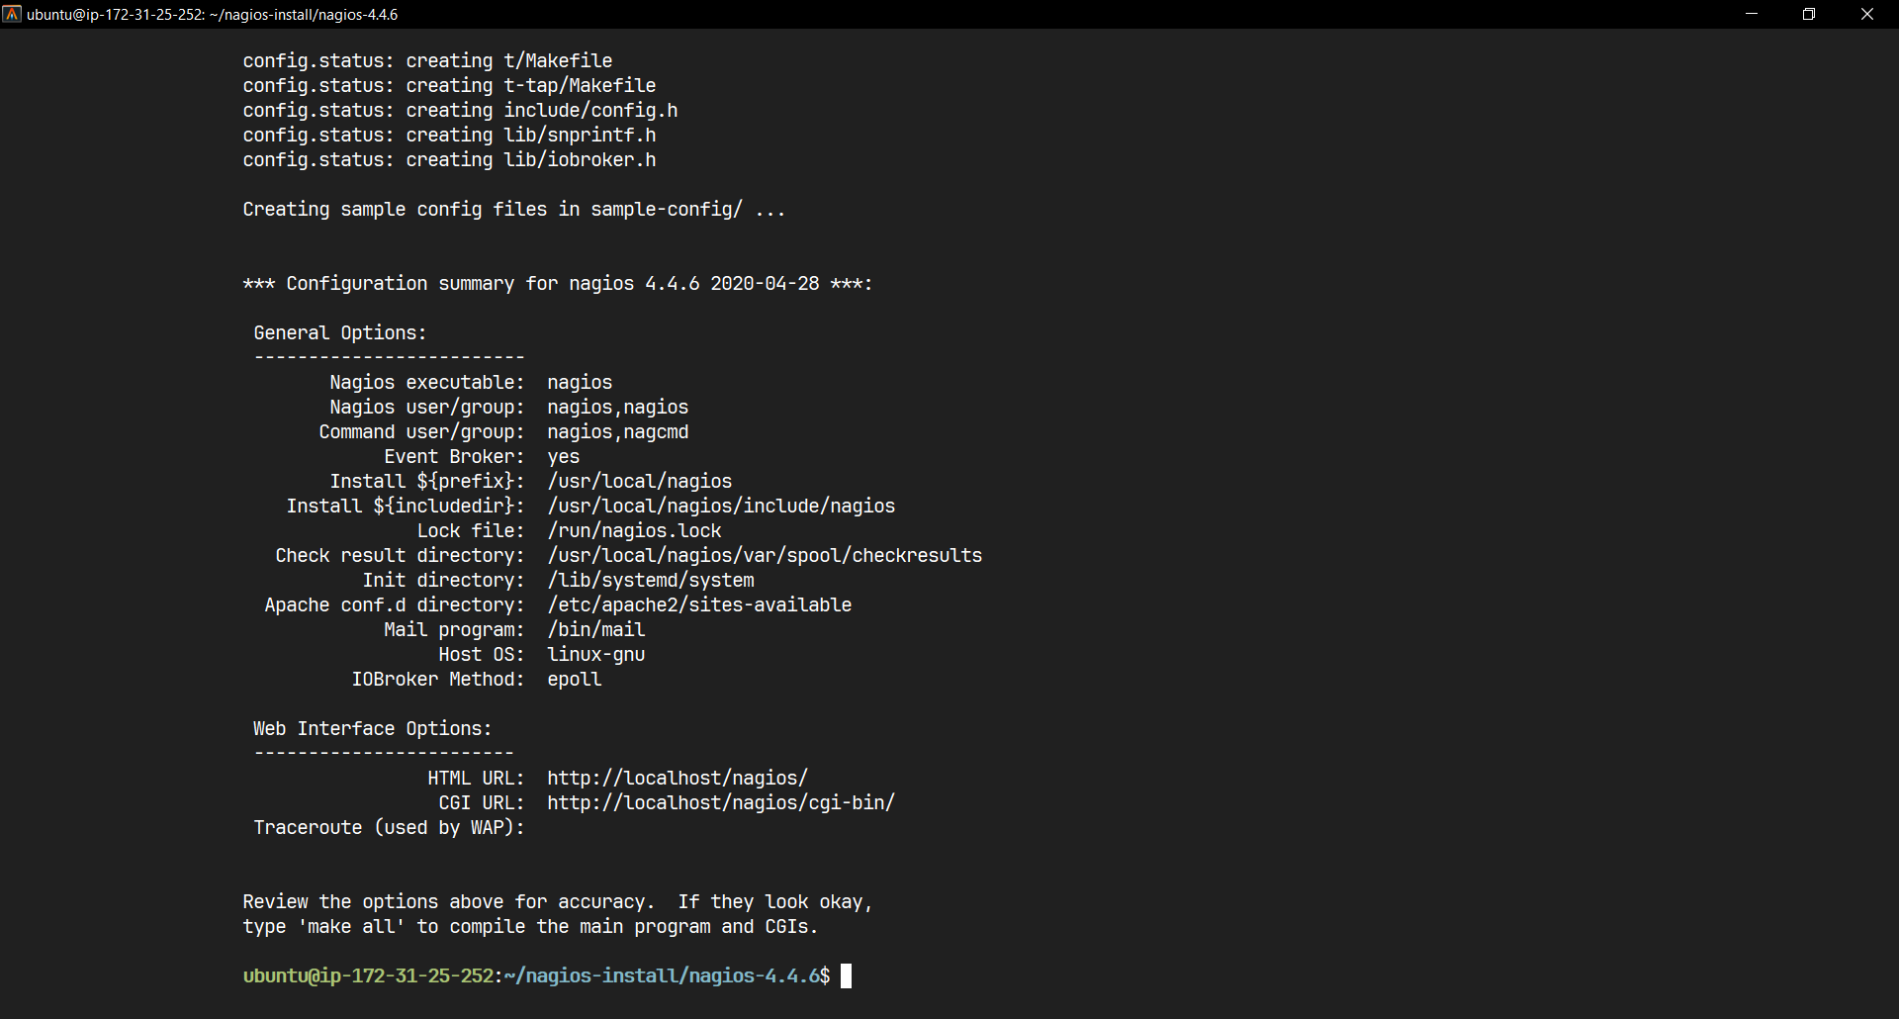

Compile and install Nagios

(./configure --with-command-group=nagcmd)

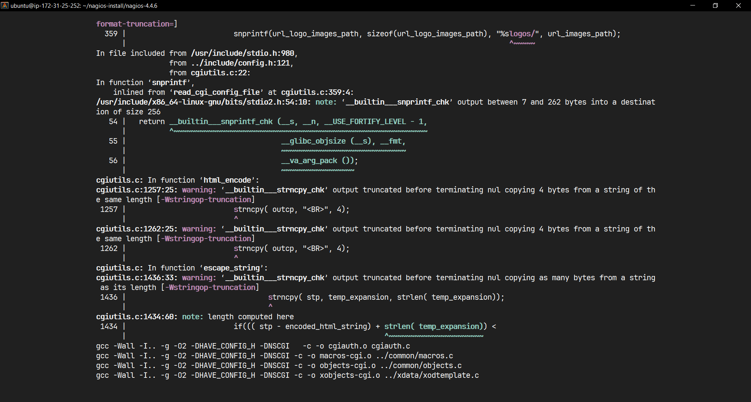

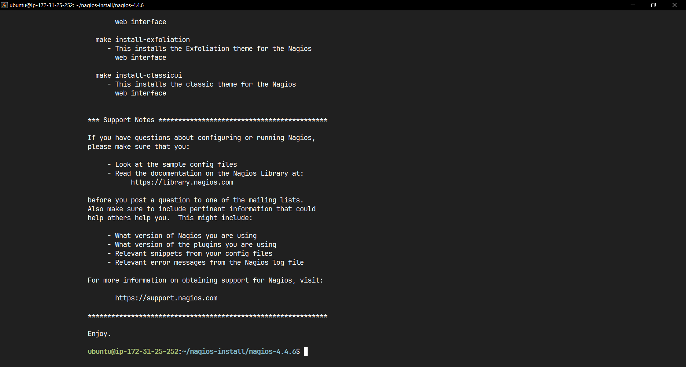

(make all) Command execution Completed

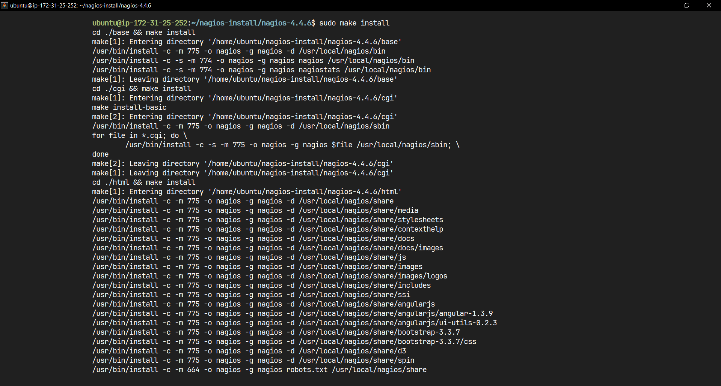

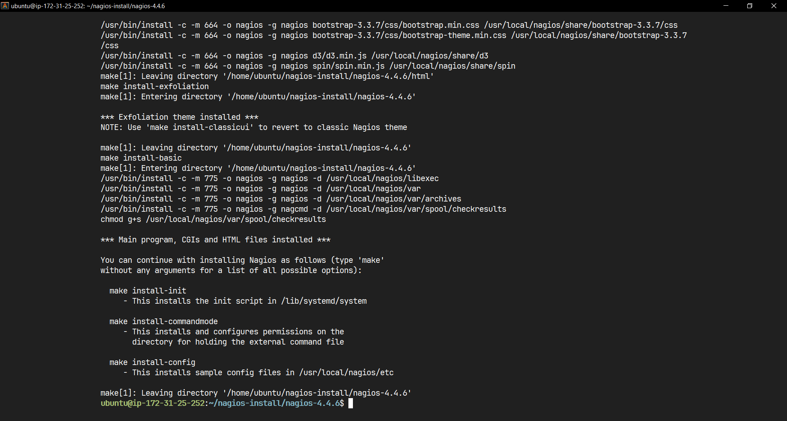

(sudo make install) Command Execution Successful

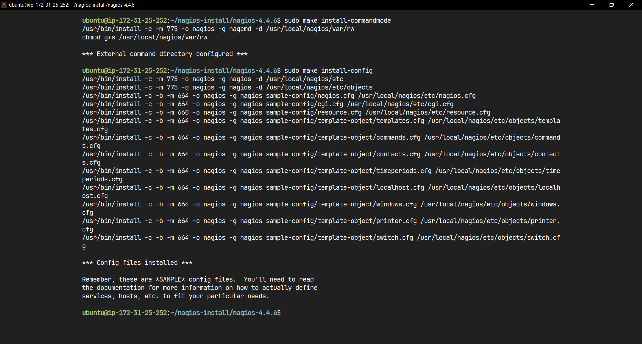

Installing Command Mode and configuration files

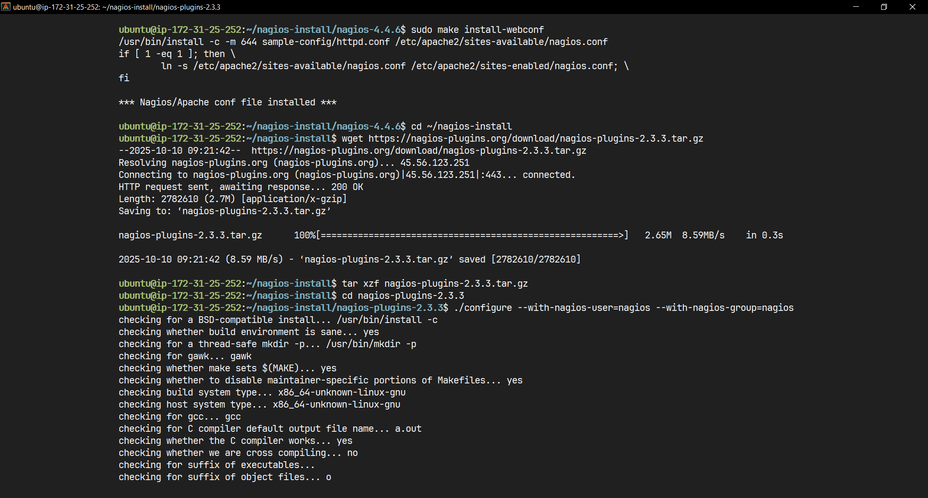

Install Web Configuration and Nagios Plugins

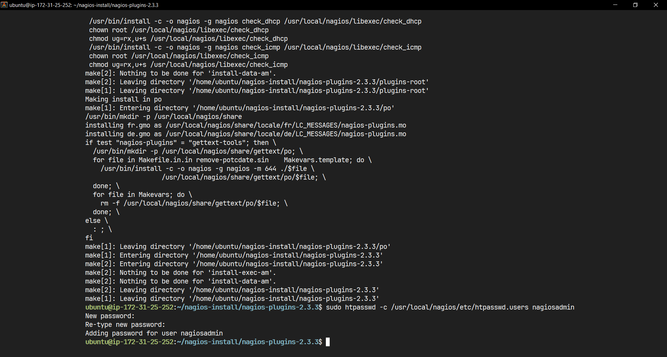

make, sudo make install and setting password

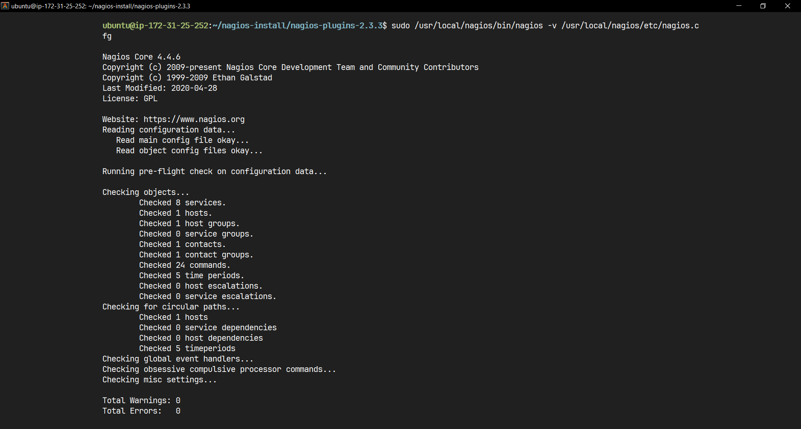

Verifying configuration

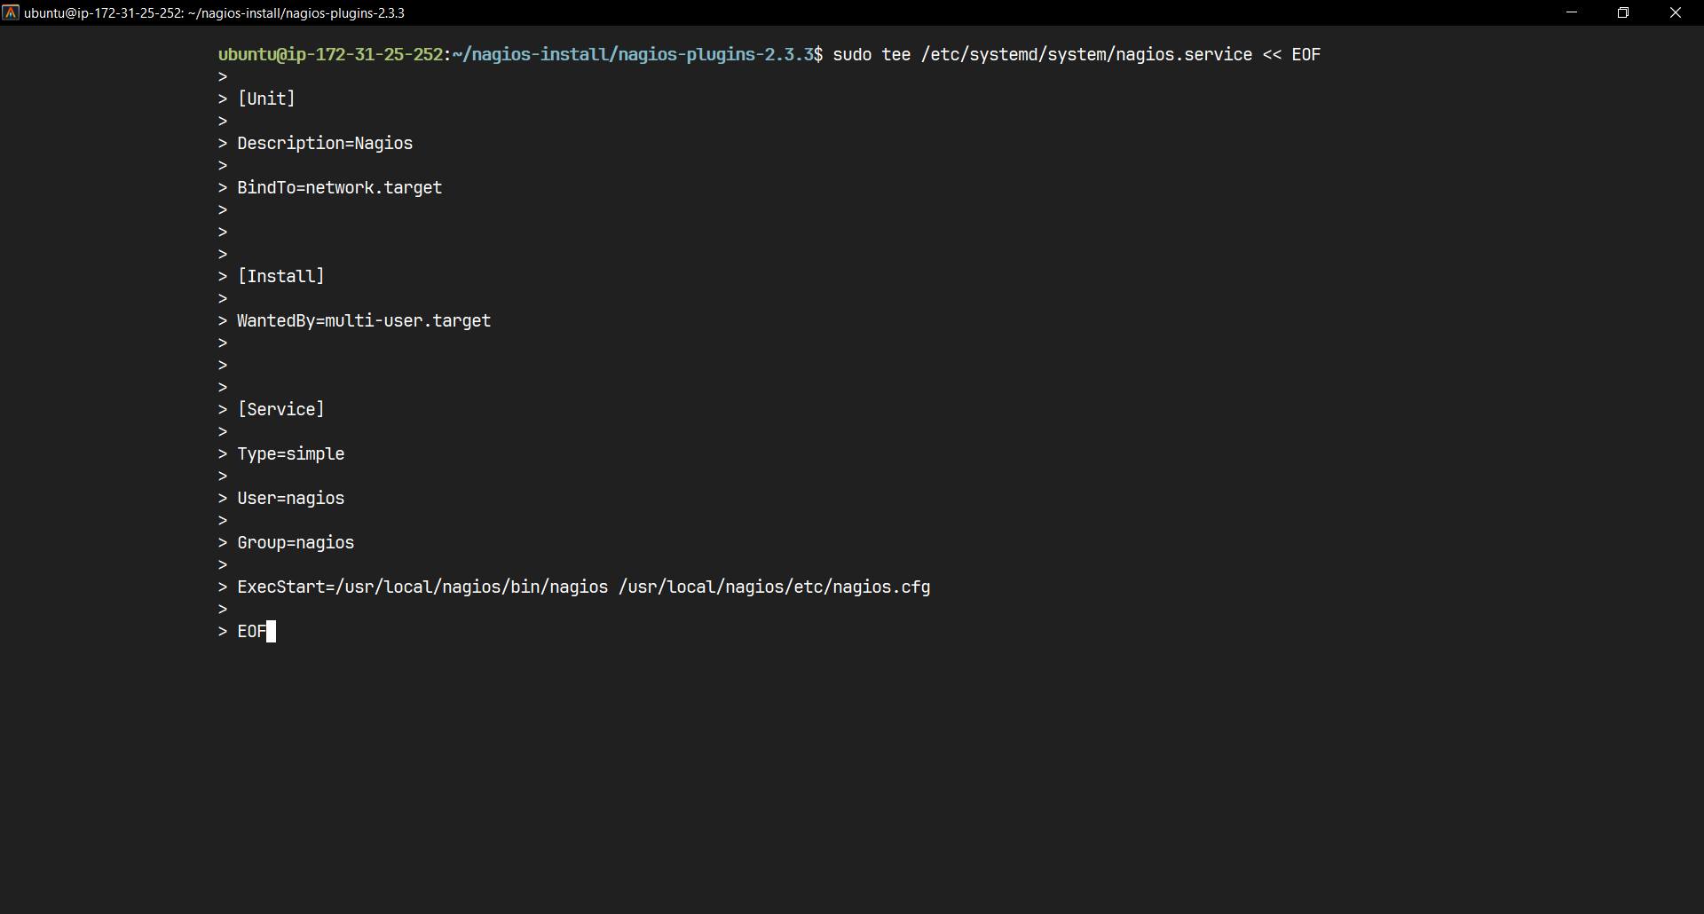

Creating systemd service file

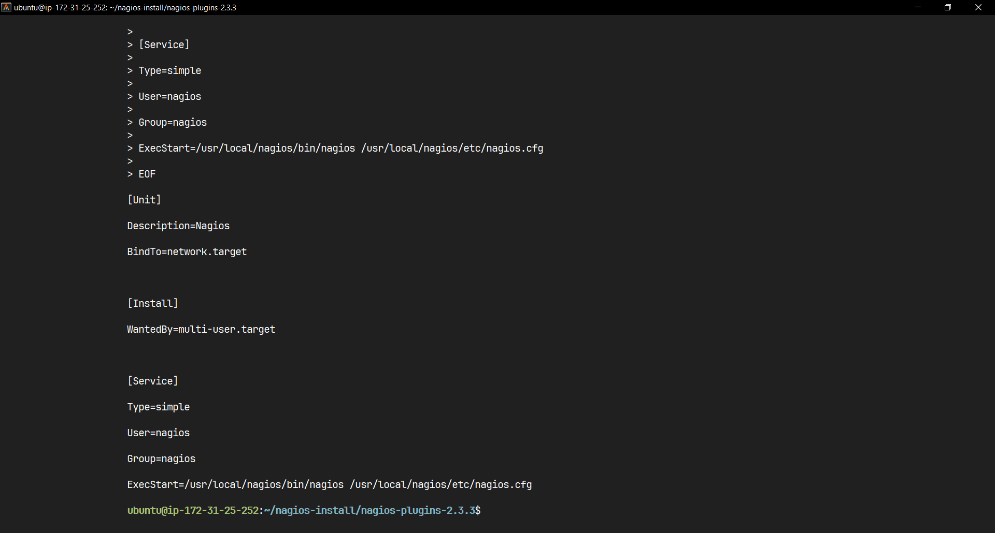

Output of the command

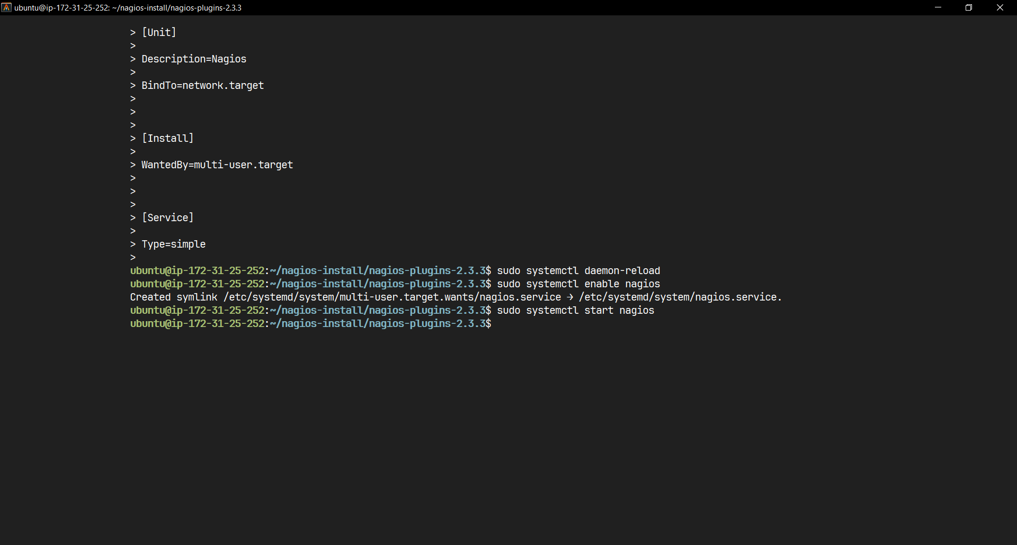

Enabling and start Nagios

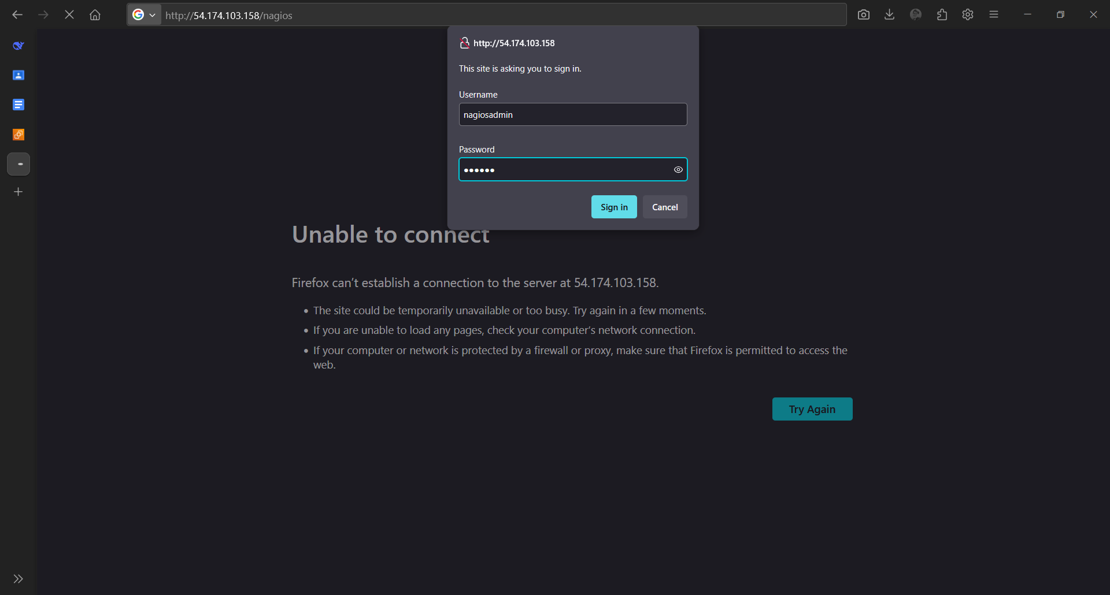

Logging to Nagios

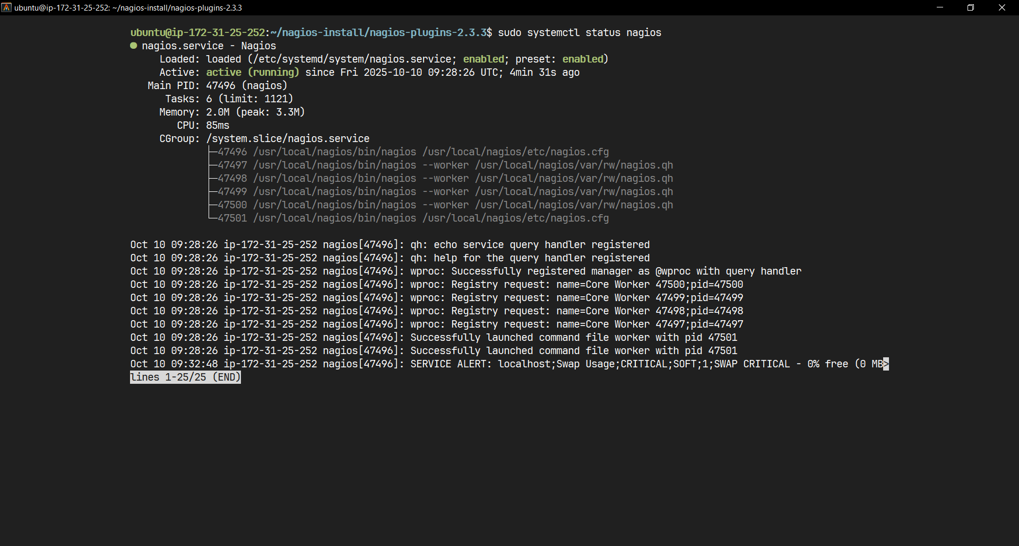

Checking Nagios Service Status

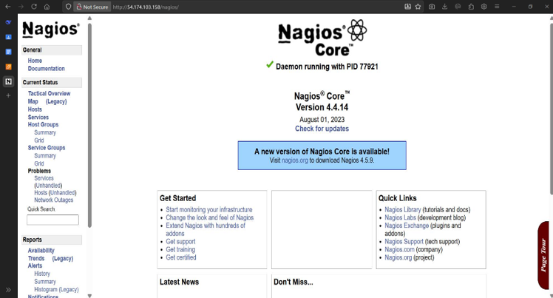

Final Output Nagios Dashboard

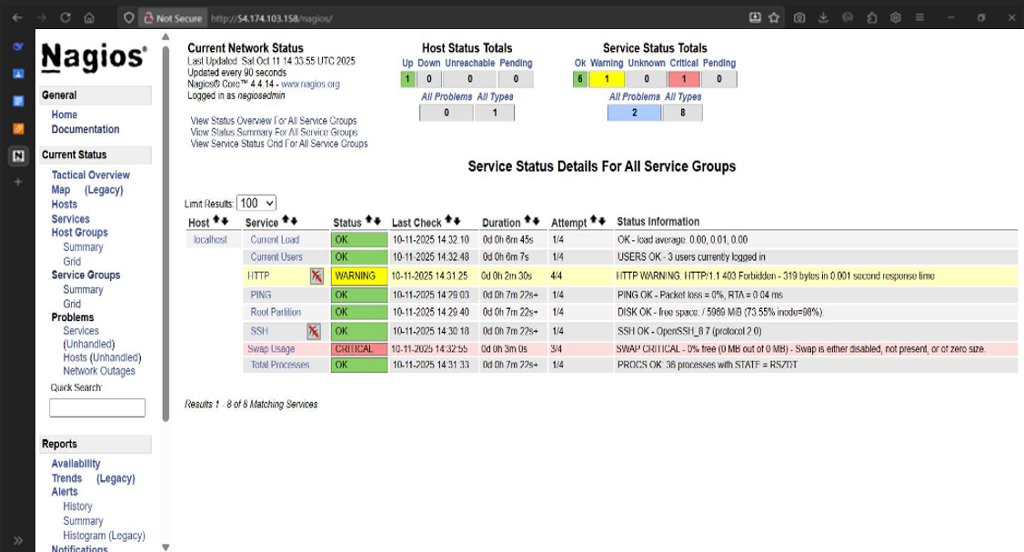

Services Available of Dashboard on Nagios

Complete Nagios Installation Script:

#!/bin/bash

# Nagios Complete Installation Script

# Save this as install_nagios.sh and run: bash install_nagios.sh

echo "Starting Nagios Installation..."

# Step 1: Update system and install dependencies

echo "Step 1: Installing dependencies..."

sudo apt update && sudo apt upgrade -y

sudo apt install -y wget build-essential apache2 php openssl perl make \

php-gd libgd-dev libapache2-mod-php libperl-dev libssl-dev daemon unzip

# Step 2: Create Nagios user and group

echo "Step 2: Creating Nagios user and group..."

sudo useradd nagios

sudo groupadd nagcmd

sudo usermod -a -G nagcmd nagios

sudo usermod -a -G nagcmd www-data

# Step 3: Create installation directory and download Nagios

echo "Step 3: Downloading Nagios Core..."

mkdir ~/nagios-install

cd ~/nagios-install

wget https://assets.nagios.com/downloads/nagioscore/releases/nagios-4.4.6.tar.gz

tar xzf nagios-4.4.6.tar.gz

cd nagios-4.4.6

# Step 4: Compile and install Nagios Core

echo "Step 4: Compiling and installing Nagios Core..."

./configure --with-command-group=nagcmd

make all

sudo make install

sudo make install-commandmode

sudo make install-config

sudo make install-webconf

# Step 5: Install Nagios Plugins

echo "Step 5: Installing Nagios Plugins..."

cd ~/nagios-install

wget https://nagios-plugins.org/download/nagios-plugins-2.3.3.tar.gz

tar xzf nagios-plugins-2.3.3.tar.gz

cd nagios-plugins-2.3.3

./configure --with-nagios-user=nagios --with-nagios-group=nagios

make

sudo make install

# Step 6: Configure Apache and set password

echo "Step 6: Configuring Apache..."

sudo htpasswd -c /usr/local/nagios/etc/htpasswd.users nagiosadmin

# Step 7: Set proper permissions

echo "Step 7: Setting permissions..."

sudo chown -R nagios:nagios /usr/local/nagios/etc/

sudo chown -R nagios:nagios /usr/local/nagios/var/

sudo mkdir -p /usr/local/nagios/var/spool/checkresults

sudo chown nagios:nagcmd /usr/local/nagios/var/spool/checkresults

sudo chmod 775 /usr/local/nagios/var/spool/checkresults

# Step 8: Create systemd service

echo "Step 8: Creating systemd service..."

sudo tee /etc/systemd/system/nagios.service << EOF

[Unit]

Description=Nagios

BindTo=network.target

[Install]

WantedBy=multi-user.target

[Service]

Type=simple

User=nagios

Group=nagios

ExecStart=/usr/local/nagios/bin/nagios /usr/local/nagios/etc/nagios.cfg

EOF

# Step 9: Verify configuration

echo "Step 9: Verifying configuration..."

sudo /usr/local/nagios/bin/nagios -v /usr/local/nagios/etc/nagios.cfg

# Step 10: Start services

echo "Step 10: Starting services..."

sudo systemctl daemon-reload

sudo systemctl enable nagios

sudo systemctl start nagios

sudo systemctl restart apache2

# Step 11: Get server IP for access

echo "Step 11: Getting server information..."

PUBLIC_IP=$(curl -s http://169.254.169.254/latest/meta-data/public-ipv4)

PRIVATE_IP=$(curl -s http://169.254.169.254/latest/meta-data/local-ipv4)

echo "================================================"

echo "Nagios Installation Complete!"

echo "================================================"

echo "Access Nagios at: http://$PUBLIC_IP/nagios"

echo "Username: nagiosadmin"

echo "Password: [the password you set during installation]"

echo "================================================"

echo "Check Nagios status: sudo systemctl status nagios"

echo "Check Nagios logs: sudo tail -f /usr/local/nagios/var/nagios.log"

echo "================================================"